|  |  |  |
| --- | --- | --- |
| **Report of** | **Meeting** | **Date** |
| Director of Planning and Development | Licensing and Public Safety Committee  Council | Tuesday, 7 December 2021  Tuesday, 26 January 2022 |



|  |  |
| --- | --- |
| Is this report confidential? | No |

|  |  |
| --- | --- |
| Is this decision key? | Not applicable |

# Revised Gambling Policy 2022 – 2025

# Purpose of the Report

1. This report is to outline to Members the proposed revisions required to the Council’s Statement of Licensing Policy (Gambling). The last Gambling Policy was published on 31st January 2019 and us due to expire on the 31st January 2022.

**Recommendations to Licensing and Public Safety Committee**

1. Members should consider all revisions and recommendations for approval to full council before the 31st January 2022

**Recommendations to Council**

1. To approve the revised Gambling Policy 2022 – 2025.

## Reasons for recommendations

1. Relatively minor policy amendments are required to the existing policy, the necessary changes were highlighted in report taken to committee in December 2021.

## Other options considered and rejected

1. There are no further options to consider as under Section 349 of the Gambling Act 2005. Local Authorities are required to renew their Statement of Licensing Policy (Gambling) every 3 years.

## 

## Corporate priorities

1. The report relates to the following corporate priorities:

|  |  |
| --- | --- |
| An exemplary council | **Thriving communities** |
| A fair local economy that works for everyone | Good homes, green spaces, healthy places |

## Background to the report

## The council’s Statement of Licensing Policy (Gambling) sets out the way the council will generally promote the Licensing Objectives when considering and making decisions on applications made under the Gambling Act (the Act).

## The council’s current Statement of Policy is due to expire on the 31st of January 2022. Under the Act policies endure for a 3-year period.

1. The council is constrained by the provisions of the Act, the Guidance and any Regulations made under the Act. However, the Authority may depart from the Guidance if it has reason to do so but must give full justification for any such departure.
2. The council is required by Section 349 of the Act to publish a new Gambling policy by the 31st of January 2022. This Statement of Policy shall be effective from the 31st January 2022 and shall remain in effect for three years; therefore, this Statement will be reviewed again in January 2025.
3. South Ribble does not have a particularly wide offer of Gambling establishments with 11 Betting shops, most of which are national operators. The gaming machine offer is much broader with virtually every Licensed Premises in the Borough taking advantage of the right to site machines in their premises.

**Changes required to your Gambling Policy**

1. Below are the updates required for your Gambling Policy. Only relatively minor modifications are being proposed. This includes a minor amendment to the Local area Profile.

**Page 3, section 1.1 of your Policy currently states;**

*“The population in South Ribble is 103,900 which has remained relatively stable over the last decade following a period of rapid growth in the 1970s and 1980s.”*

**To be replaced by;**

*“The population in South Ribble is* ***111,086*** *which has remained relatively stable over the last decade following a period of rapid growth in the 1970s and 1980s.”*

*And;*

**Page 4, section 1.1 of your Policy currently shows the following data;**



**A change is required to the map to update the local area map to;**

***To be replaced by***

***To be replaced by an updated map produced on the 16th November 2021;***

**A change is required to the map to update the local area map to;**

***To be replaced by***

***To be replaced by an updated map produced on the 16th November 2021;***

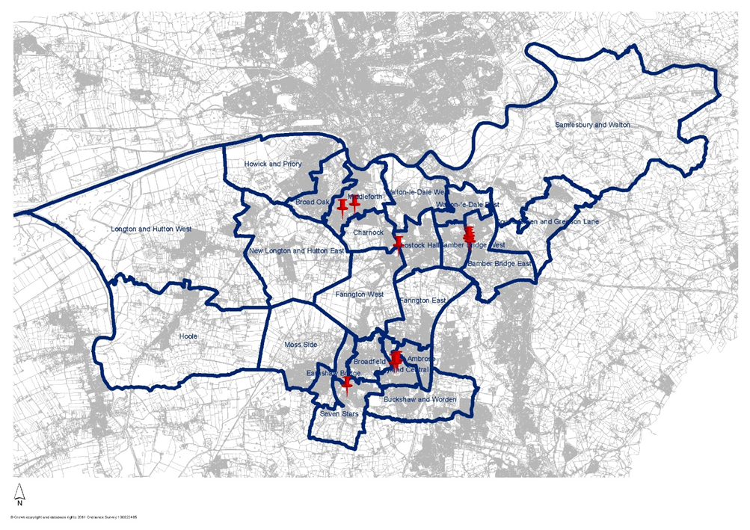

## Equality and diversity

## There are no implications within this report on equality and diversity, as this report is to simply to extend a current licensing policy.

## Risk

## If the Council fails to implement the Regulations, it may be challenged when exercising its functions.

## Climate change and air quality

## The work noted in this report does not impact the climate change and sustainability targets of the Councils Green Agenda and all environmental considerations are in place.

## Comments of the Statutory Finance Officer

1. No comment.

## Comments of the Monitoring Officer

1. The duty to review the policy every three years is referred to in the body of the report as well as the consideration of the policy in making determinations under the Gambling Act 2005.
2. Functions under section 349 of the Gambling Act 2005 including approval of the policy are reserved to full Council by virtue of Section 154(2)(c) of the 2005 Act.

Background documents

There are no background papers to this report

## Appendices

Background documents

Background Document 1 – Report to Licensing and Public Safety Committee 07/12/2021, is accessible using the below link and can be found at agenda item 5.

<https://southribbleintranet.moderngov.co.uk/ieListDocuments.aspx?CId=483&MId=2197&Ver=4>

|  |  |  |  |
| --- | --- | --- | --- |
| Report Author: | Email: | Telephone: | Date: |
| Stephanie Newby (Licensing Officer) | stephanie.newby@southribble.gov.uk | 01772 625337 | 15th November 2021 |